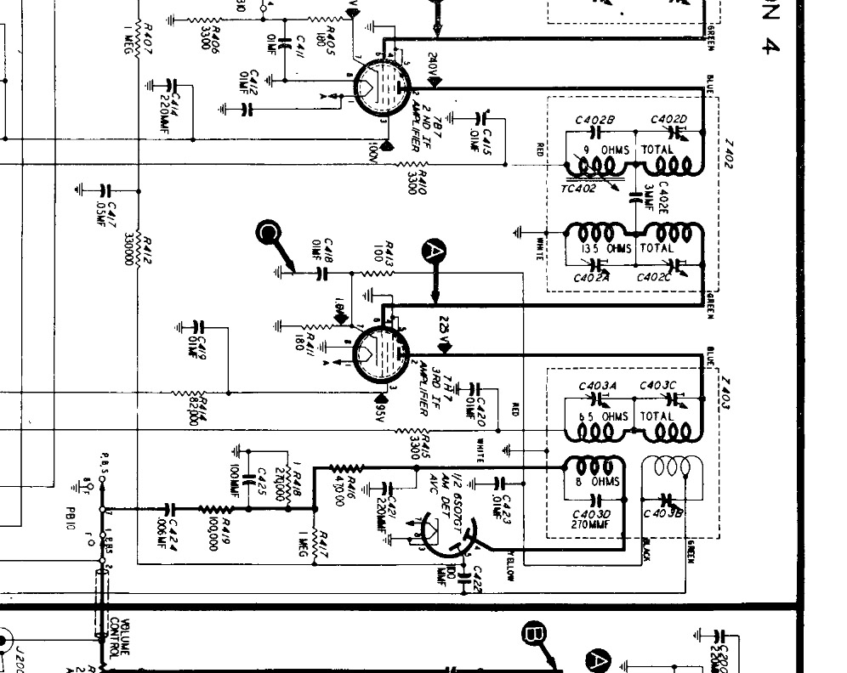
5.7 Ohms Total
>1 Ohm
8.3 Ohms
9.7 Ohms Total
14.1 Ohms Total

